**AFFORDABLE HOUSING**

*The affordable housing provided breaches the affordable housing requirements in the s106 Agreement: -*

**Rented Units**

|  |  |  |  |  |
| --- | --- | --- | --- | --- |
| Dwelling size | S106 Requirements | Provision in current layout | NOT COMPLIANT | Plot numbers |
| 2 bed (not houses) | no more than 3 | 8 | 5 units over | 103, 104, 118, 119, 139 - 142 |
| 2 bed (houses) | at least 11 | 10 | 1 unit under | 87, 88, 93, 105, 147-152 |
| 3 bed | at least 11 | 10 | 1 unit under | 83-86, 94, 95, 143, 144, 153, 154 |
| 4 bed | no more than 3 | 4 | 1 unit over | 120-123 |

**Shared ownership**

|  |  |  |  |  |
| --- | --- | --- | --- | --- |
| Dwelling size | S106 Requirements | Provision in current layout | NOT COMPLIANT | Plot numbers |
| 2 bed (not houses) | at least 7 | 5 | 2 units under | 76-78, 89, 90 |
| 3 bed | no more than 6 | 8 | 2 units over | 28-35 |

**ACCESSIBLE HOUSING**

*Building regulations say that there* ***must*** *be a living area (living room / dining room) on the same level as the front door.*

*The housing type for Plots 92, Plot 104, Plot 119 and Plot 146 is a first floor flat which does not have* ***any*** *living space on the same level as the front door. This housing type* ***cannot*** *be built to Category 2 accessible standard.*

Ground floor flat First floor flat

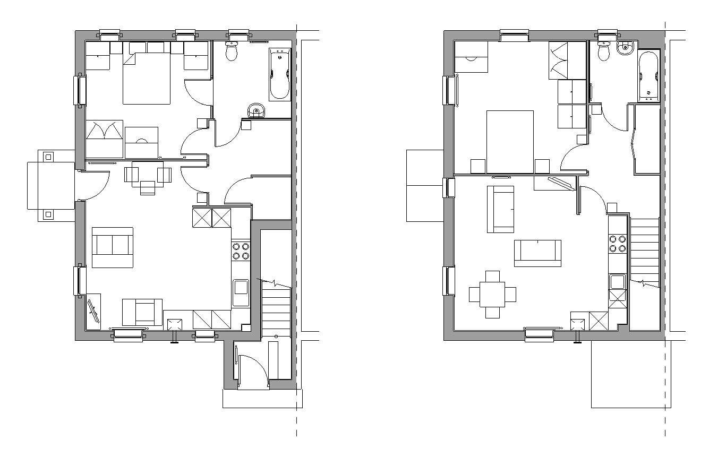



Front door to first floor flats which are supposed to be

accessible dwellings

**REPEATED ‘RESUBMISSIONS’**

**and**

**CONFUSING DOCUMENTATION**

*Condition 2 of the Outline Planning Permission says the application for approval of the reserved matters must be submitted by* ***24th September 2023*** *but the Council has just accepted a complete ‘RESUBMISSION’ of all the plans and documents which is contrary to this outline planning condition. I OJECT to this.*

*There is a total of* ***77*** *new documents uploaded to the planning portal. The applicant and Council have made it impossible for residents to understand what is relevant to the reserved matters application and what is not relevant. I therefore do not consider this ‘consultation process’ to be sound, and OBJECT to planning permission being recommended for approval on the basis that there has not been a fair, open and accessible consultation with residents.*

**23/01636/ADP**

and

**23/02826/ADP**

**THE WHOLE DEVELOPMENT**

**MUST BE ‘ACCESSIBLE’ TO**

**M4 CATEGORY 2 STANDARD**

At the outline planning stage, the Applicant’s ‘Revised VALP Compliance Table’ said that to comply with VALP Policy H6c:-

*“All of our affordable units* ***and the Private market dwellings***

*will be Cat 2 (M4(2)) compliant.”*

As a result, the Planning Officer was able to advise Members that the development would accord with VALP Policy H6c.

The Applicant is now trying to claim that only the Affordable Housing needs to be Cat 2 Compliant. I OBJECT to the Applicant so blatantly changing their position on this issue at this stage in the planning process.

It would be unlawful for the Planning Officer to recommend approval when the reserved matters application is fundamentally different from what was approved at outline stage.

**SAFETY FLAWS WITH THE MINI ROUNDABOUT**

1. **STOPPING SIGHT DISTANCE** coming from the Towcester Road is not positioned correctly. It should be measured 50m from the Give Way line of the mini-roundabout itself.
2. **RIGHT HAND VISIBILITY SPLAY** on Walnut Drive is not positioned correctly. It should be measured from the edge of the right hand approach arm, not 1m in from the edge.
3. **NO PROVISION FOR PEDESTRIANS** on either side of the narrow Main Street approach arm. This is a well-used route for children catching the school bus from the Towester road, and other pedestrians walking to Buckingham.

COMPROMISE OF THESE ROAD SAFETY STANDARDS LEADS TO

A car approaching the roundabout from Walnut Drive will not have clear visibility of vehicles approaching from the right hand side……

Vehicles approaching from the right hand side do not have the 50m stopping sight distance…….

A likely collision will result in the vehicle from Walnut Drive being shunted down Main Street which is a narrow street heavily used by pedestrians…..

With no provision for pedestrians they are in serious danger of being hit!!!